1. **Gantt Chart**

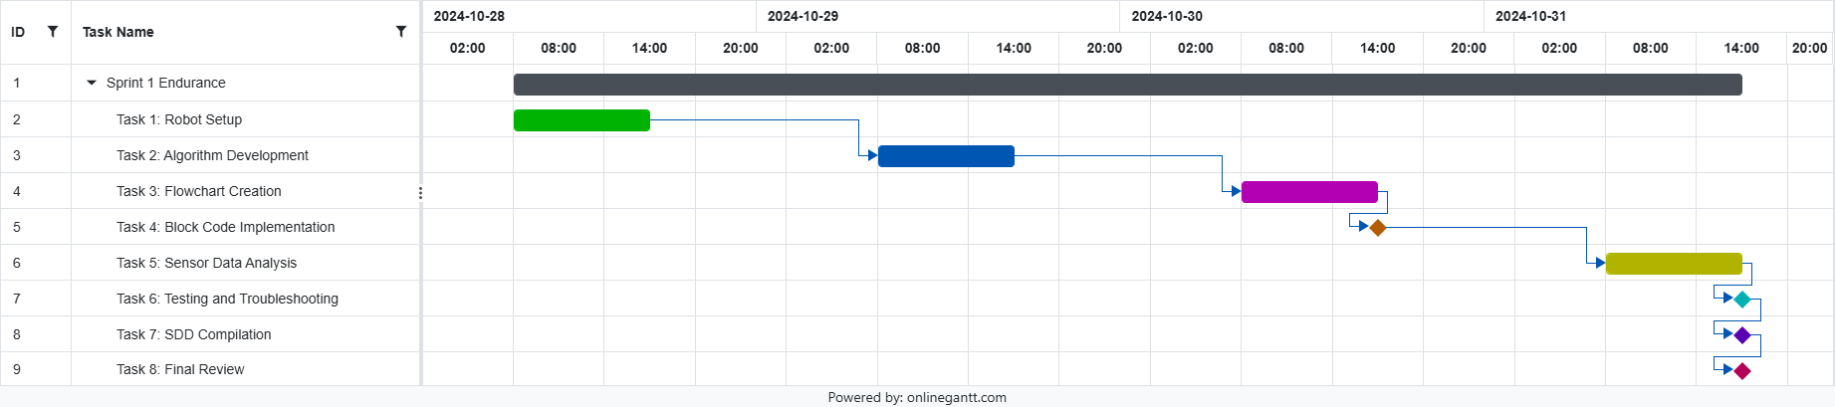

1. **Requirements Table**

| **Requirement ID** | **Description** | **Status** |
| --- | --- | --- |
| R1 | Robot must move in a rectangular pattern | Complete |
| R2 | Flowchart must match the algorithm steps | Complete |
| R3 | Block code must drive the Sphero Bolt | Complete |
| R4 | Sensor data must be collected and analyzed | Complete |

1. **Requirments Signoff Table**

| **Requirement ID** | **Signoff By** | **Date** |
| --- | --- | --- |
| R1 | Isaac and Bilal | 11/1/24 |
| R2 | Isaac and Bilal | 11/1/24 |
| R3 | Isaac and Bilal | 11/1/24 |
| R4 | Isaac and Bilal | 11/1/24 |

1. **Algorithm**

* Start
* Move forward at 255 speed for 3.9 seconds
* Delay 2 seconds
* Turn left and move forward at 255 speed for 2.3 seconds
* Delay 2 seconds
* Turn left and move forward at 255 speed for 4 seconds
* Delay 2 seconds
* Turn left and move forward at 255 speed for 2.3 seconds
* End.

1. **Flowchart**

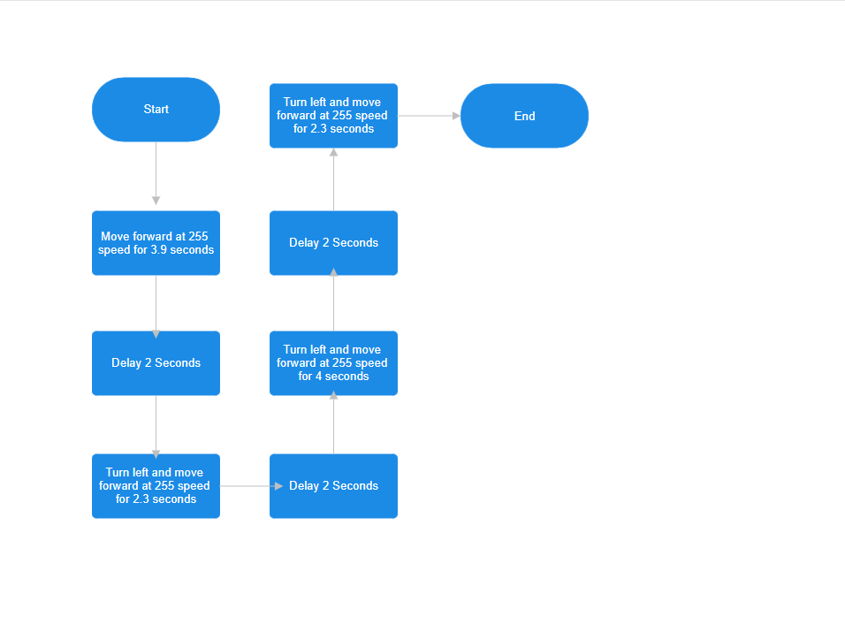

1. **Block Code**

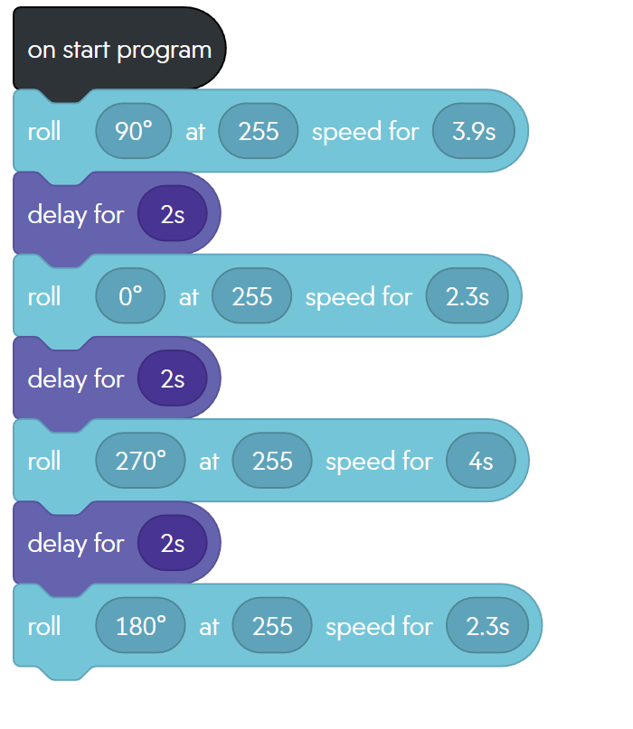

1. **Sensor Data Diagram (for some reason it won’t update to the new one, so this is a little bit of an older version)**

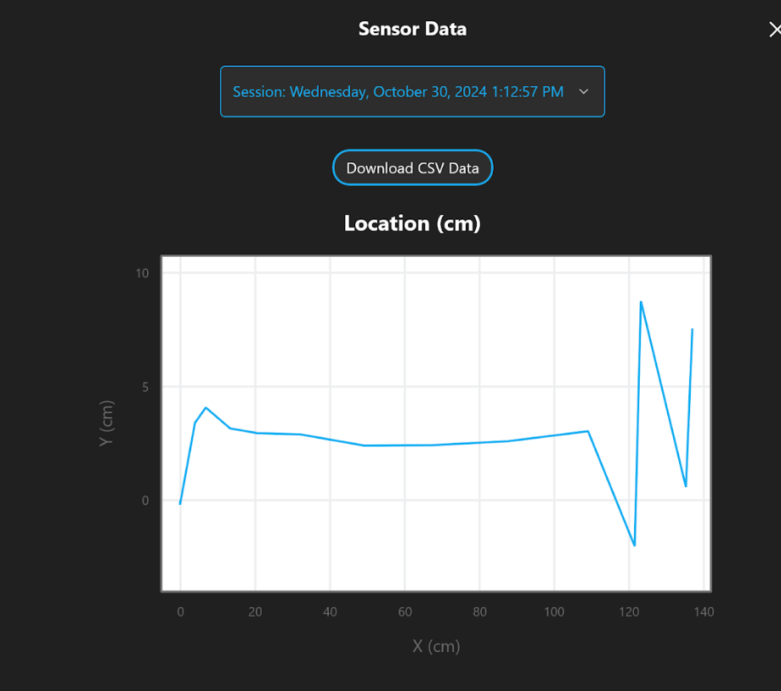

1. **Test Table**

| **Test Case** | **Description** | **Expected Outcome** | **Actual Outcome** | **Pass/Fail** |
| --- | --- | --- | --- | --- |
| TC1 | Move forward for 4 seconds | Robot moves perfectly straight for 4 seconds | Robot moved mostly straight for 4 seconds | Pass |
| TC2 | Turn left and move foward | Robot turns perfectly left and moves foward | Robot turned left with slight degrees of error | Pass |
| TC3 | Complete full rectangle | Robot follows the line through the entire rectangle | Robot stayed as close as possible to the line for the entire rectangle | Pass |

1. **Staffing Plan**

| **Name** | **Title** | **Responsibilities** |
| --- | --- | --- |
| Isaac Sasson | Group leader | Submit project and create github |
| Bilal Shweb | Group member | Assist with the project and github |